UNITED STATES
SECURITIES AND EXCHANGE COMMISSION
Washington, D.C. 20549
SCHEDULE 14A
Proxy Statement Pursuant to Section 14(a) of the Securities
Exchange Act of 1934 (Amendment No. )
Filed by the Registrant ☒
Filed by a Party other than the Registrant ☐
Check the appropriate box:

☐ | Preliminary Proxy Statement
☐ | Confidential, for Use of the Commission Only (as permitted by Rule 14a-6(e)(2))
☐ | Definitive Proxy Statement
☒ | Definitive Additional Materials
☐ | Soliciting Material Pursuant to §240.14a-12

Definitive Healthcare Corp.
(Name of Registrant as Specified In Its Charter)

(Name of Person(s) Filing Proxy Statement, if other than the Registrant)
Payment of Filing Fee (Check all boxes that apply):

☒ | No fee required
☐ | Fee paid previously with preliminary materials
☐ | Fee computed on table in exhibit required by Item 25(b) per Exchange Act Rules 14a-6(i)(1) and 0-11

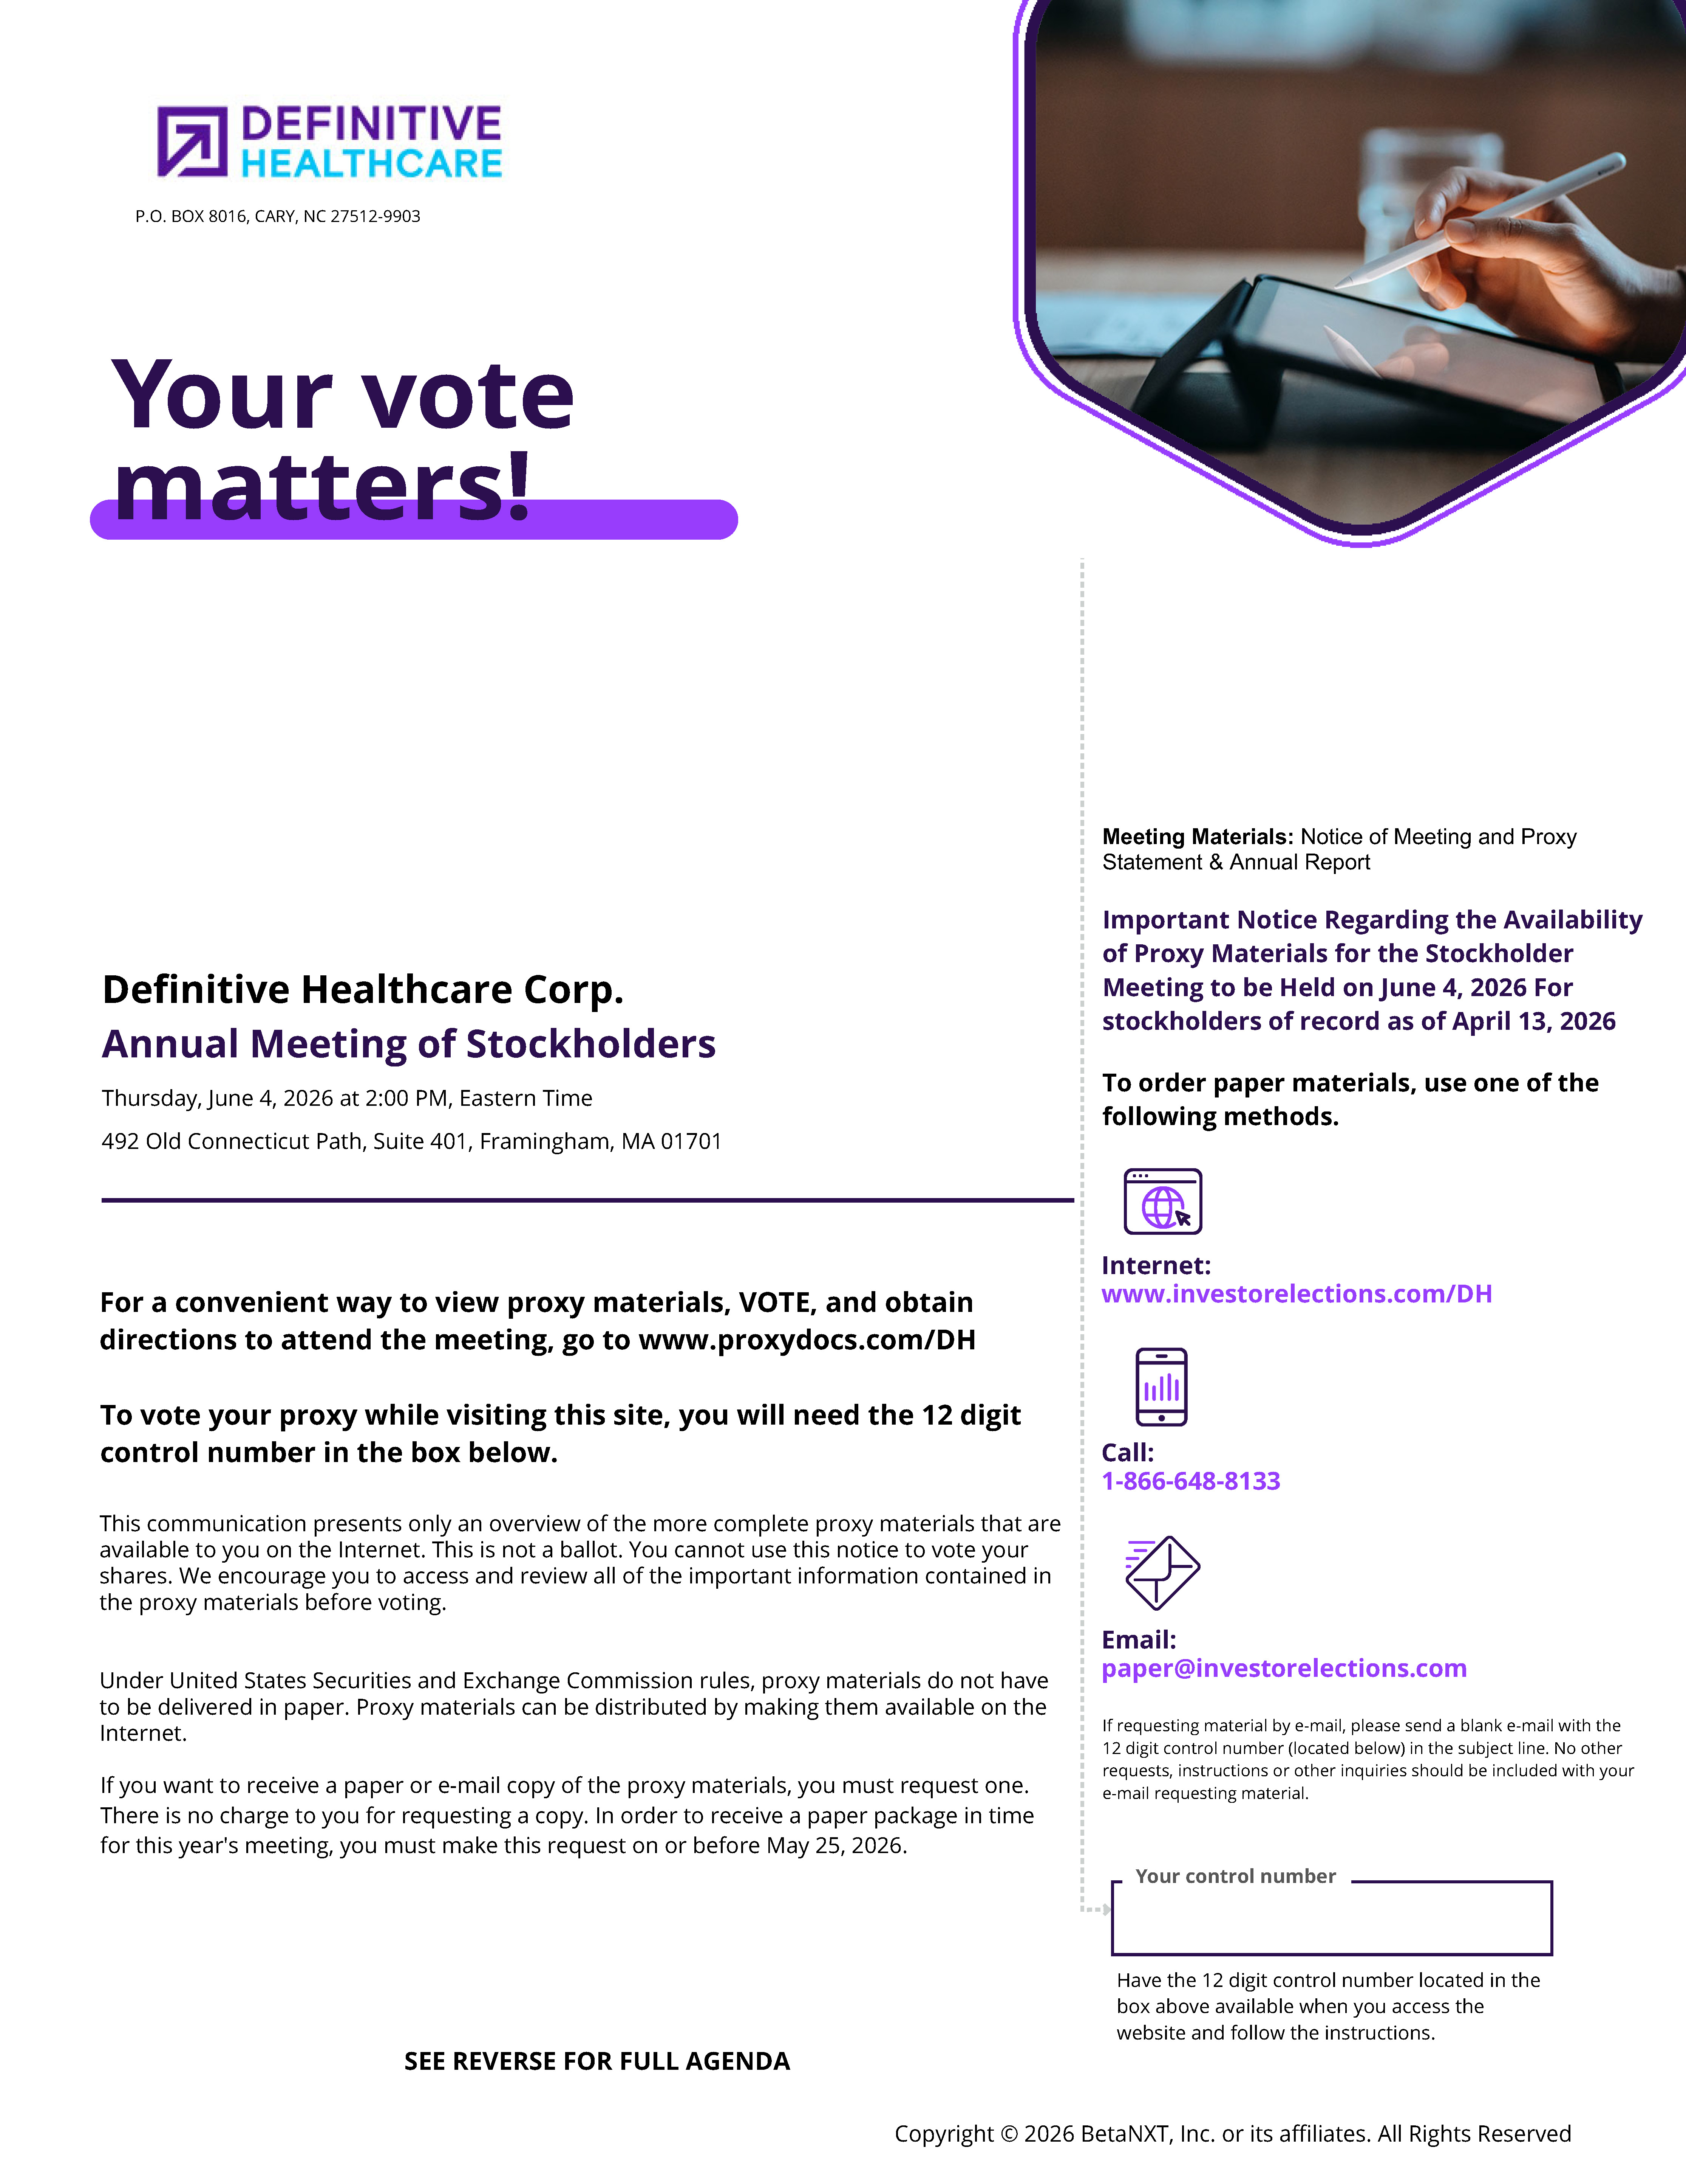
P.O. BOX 8016, CARY, NC 27512-9903 Your vote matters! Definitive Healthcare Corp. Annual Meeting of Stockholders Thursday, June 4, 2026 at 2:00 PM, Eastern Time 492 Old Connecticut Path, Suite 401, Framingham, MA 01701 styleINA Meeting Materials: Notice of Meeting and Proxy Statement & Annual Report Important Notice Regarding the Availability of Proxy Materials for the Stockholder Meeting to be Held on June 4, 2026 For stockholders of record as of April 13, 2026 To order paper materials, use one of the following methods. For a convenient way to view proxy materials, VOTE, and obtain directions to attend the meeting, go to www.proxydocs.com/DH To vote your proxy while visiting this site, you will need the 12 digit control number in the box below. This communication presents only an overview of the more complete proxy materials that are available to you on the Internet. This is not a ballot. You cannot use this notice to vote your shares. We encourage you to access and review all of the important information contained in the proxy materials before voting. Under United States Securities and Exchange Commission rules, proxy materials do not have to be delivered in paper. Proxy materials can be distributed by making them available on the Internet. If you want to receive a paper or e-mail copy of the proxy materials, you must request one. There is no charge to you for requesting a copy. In order to receive a paper package in time for this year's meeting, you must make this request on or before May 25, 2026. Internet: www.investorelections.com/DH Call: 1-866-648-8133 Email: paper@investorelections.com If requesting material by e-mail, please send a blank e-mail with the 12 digit control number (located below) in the subject line. No other requests, instructions or other inquiries should be included with your e-mail requesting material. Your control number Have the 12 digit control number located in the box above available when you access the website and follow the instructions. SEE REVERSE FOR FULL AGENDA Copyright © 2026 BetaNXT, Inc. or its affiliates. All Rights Reserved

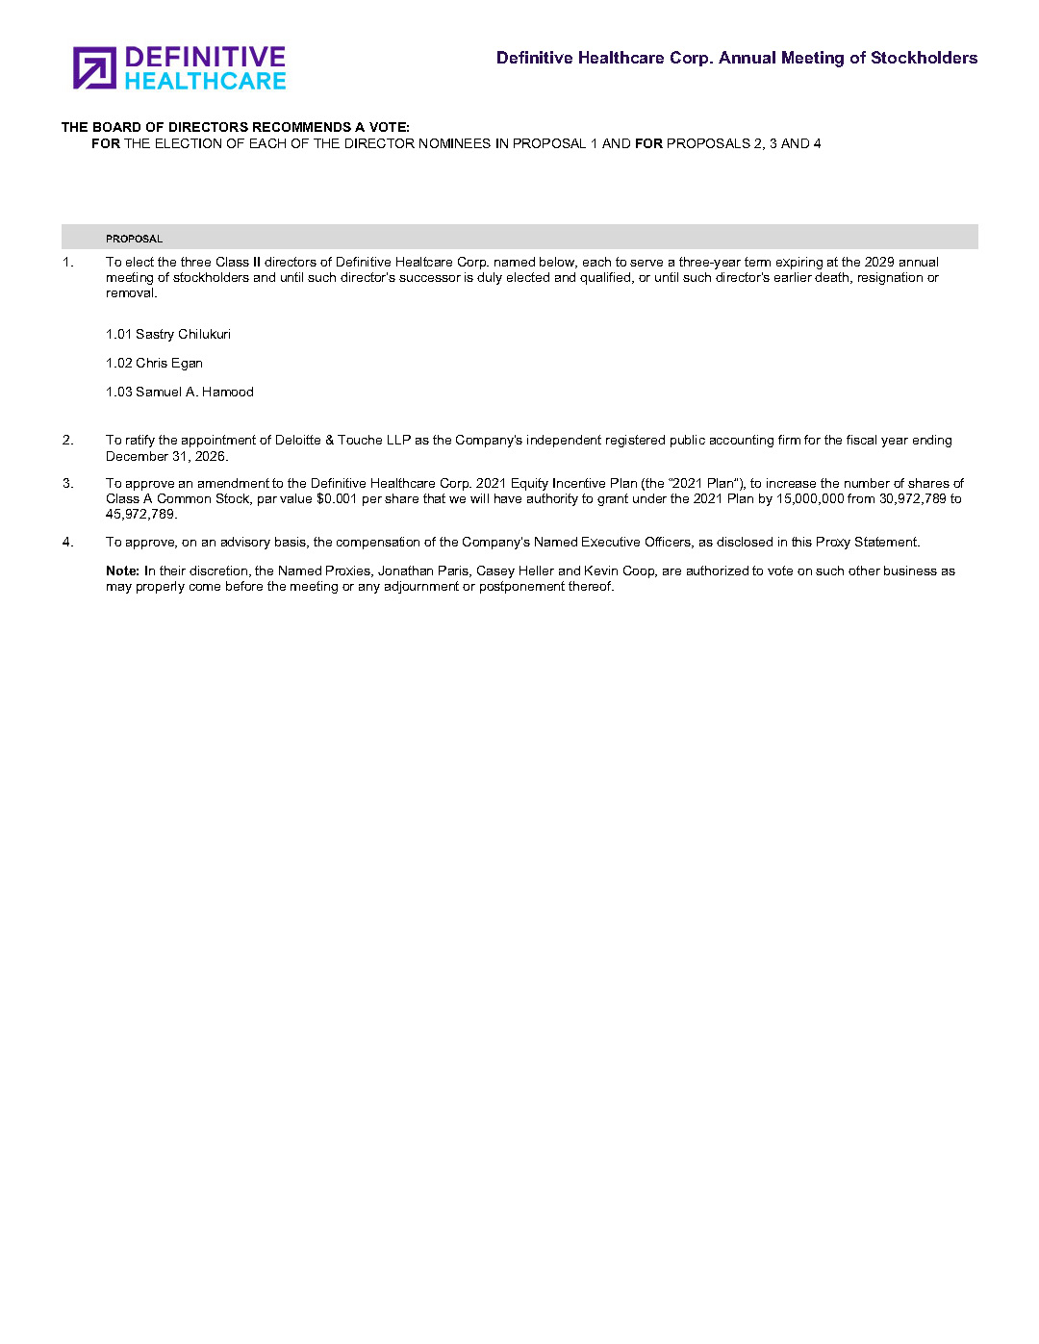
Definitive Healthcare Corp. Annual Meeting of Stockholders THE BOARD OF DIRECTORS RECOMMENDS A VOTE: FOR THE ELECTION OF EACH OF THE DIRECTOR NOMINEES IN PROPOSAL 1 AND FOR PROPOSALS 2, 3 AND 4 PROPOSAL 1. To elect the three Class II directors of Definitive Healtcare Corp. named below, each to serve a three-year term expiring at the 2029 annual meeting of stockholders and until such director's successor is duly elected and qualified, or until such director's earlier death, resignation or removal. 1.01 Sastry Chilukuri 1.02 Chris Egan 1.03 Samuel A. Hamood 2. To ratify the appointment of Deloitte & Touche LLP as the Company's independent registered public accounting firm for the fiscal year ending December 31, 2026. 3. To approve an amendment to the Definitive Healthcare Corp. 2021 Equity Incentive Plan (the “2021 Plan”), to increase the number of shares of Class A Common Stock, par value $0.001 per share that we will have authority to grant under the 2021 Plan by 15,000,000 from 30,972,789 to 45,972,789. 4. To approve, on an advisory basis, the compensation of the Company’s Named Executive Officers, as disclosed in this Proxy Statement. Note: In their discretion, the Named Proxies, Jonathan Paris, Casey Heller and Kevin Coop, are authorized to vote on such other business as may properly come before the meeting or any adjournment or postponement thereof.

